
Artificial Intelligence (Lab)
Lab1 Report

Submitted By:
Wajahat Aftab
SU92-BSSEM-S25-002
BSSEM-4A

Submitted To:
Sir. Rasikh Ali

Task 01: Timeline of Artificial Intelligence
- Introduction:
This Timelines shows the important events in the history of Artificial Intelligence. It includes the early development of AI a period when AI research slowed down and a modern development in deep learning.
- Milestones of Artificial Intelligence:

Year | Event | Significance | Source
1950 | Alan Turing | Alan Turing publishes "competing Machinery and Intelligence " and introduces the turing test to evaluate machine intelligence | Wikipedia
1956 | Dartmouth Conference | The Dartmouth conference coins the term "Artificial Intelligence "officially founding the field | Dartmouth College:
1957 | Perceptron | Frank Rosenblatt introduces the perceptron an early neural network capable of basic pattern recoginition | Smithsonian Institution
1973-1980s | AI Winter | Funding cuts and overpromising trigger the first and second "AI Winters" slowing research progress | Wikipedia
2012 | Alex Net | Alex Net wins the image Net competition via deep learning triggering as massive surge in computer vision | Pinecone

- References:
- Alan Turing (1950): computing machinery and intelligence Wikipediahttps://en.wikipedia.org/wiki/Computing_Machinery_and_Intelligence
- Dartmouth College (1956): The founding and future of AIhttps://ai.dartmouth.edu/founding-and-future-ai
- Perceptron (1957): Smithsonian Institution https://americanhistory.si.edu/collections/object/nmah_334414
- AI Winter (1973-1980s): Wikipedia contributors AI Winter https://en.wikipedia.org/wiki/AI_winter
- Alex Net (2012): Pinecone Image Net https://www.pinecone.io/learn/series/image-search/imagenet/

Task 02: Rule Based Scholarship Agent
- Objective:
The purpose of this task was to improve the scholarship program by adding two more conditions and checking how it works with different student records.
- Implementation:
I used python to make a simple scholarship agent.it stores the student's details in a dictionary called state and checks whether the student meets the given conditions. If all conditions are met the result is Review. if any condition is not met the result is false.
The program checks these four conditions:
- The student's score should be 70 or above
- All required documents should be complete
- Attendance should be at least 75%
- The student should have no disciplinary cases
The attendance and disciplinary conditions were selected as assumptions for this lab task. They are not actual university scholarship policies.
- Testing and Result:
Test case | Student Details (score, documents, attendance, cases) | Expected Result | Actual result
pass | 85, true, 90, 0 | Review | Review
Low Attendance | 85, true, 60, 0 | Hold | Hold
Disciplinary Issue | 85, true, 95, 2 | Hold | Hold
Boundary Score | 70, true, 95, 0 | Review | Review
All four test cases gave the expected results.
- Why I Select these Test Cases:
I selected these cases to check different situations. In the first case the student meets all the conditions. In the second case the attendance is below 75% so the result should be Hold. In the third case the student has two disciplinary cases which also leads to Hold. The last case uses a score of exactly 70 to check whether the minimum score is accepted.
- Conclusion:
The program worked correctly for all four test cases. It accepted the student who met all the conditions and returned Hold when a condition was not satisfied. The boundary test also showed that a score of exactly 70 is accepted. However, Review only means that the student meets the conditions used in this program; it does not mean that the scholarship has been approved.

Task 03: Conversational Test and Task Performance
- Objective:
The purpose of this task was to understand the difference between giving a good conversational answer and performing a task correctly. I used the scholarship example to compare these two approaches.
- Implementation:
I created a python program named lab1_compare.py. the program compares a conversational answer with the result of checking the scholarship conditions.
In the first case the answer says the student should get Review because the score is 85 and the documents are complete. However it ignores the attendance requirement. In the second case the answer considers the attendance condition as well.
- Testing and Result:
I tested the program with two cases to check the task decision.
Test Case | Expected Result | Actual Result
Fluent but incorrect answer | Hold | Hold
Correct task decision | Hold | Hold

Both test cases passed because the program returned the expected task decision.
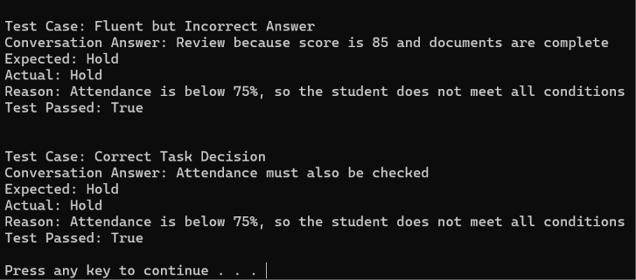
- Output:

- What does a conversational Test Show:
A conversational test checks how well a system responds to question and communicates with a user. A clear and fluent answer may sound correct but it does not always mean that the answer is accurate. For example a system might recommend Review for a student without checking the attendance requirement.
- Why is Task Performance Important:
Task performance checks whether a system can complete a specific task correctly. In this example, the system must check the score, documents, attendance, and disciplinary record before making a decision. Since the student's attendance is only 60%, the correct result is Hold.
- Conclusion:
This task helped me understand that a good conversational answer is not enough to prove general intelligence. A system may explain something well but still miss an important condition. Therefore, its answers should also be checked against the actual task requirements. The program demonstrates this difference using a simple scholarship example.

